Print Folder & File Tree - Code Source

1-Print Folder & File Tree - Ai Question - id 3
# Source: Person Source: Provided by: [Data Path: Persons Table -> ID Column: 1, Name_En Column: Motasem Essam] Written by: [Data Path: Persons Table -> ID Column: 1, Name_En Column: Motasem Essam] on [11/19/2025]
give me code to make me choose folder from window then write folders and subfolders as tree to give me this result
give me options to ignores files and folder I didn’t want to print them
Commandos Behind Enemy Lines (2.51 GB)/
├── 1-Core (56.3 MB)/
│
├── 2-Documentation (197 MB)/
│ ├── 1-Manuals
│ │
│ ├── 2-Guides & Walkthroughs/
│ │ ├── 1-GameSpot Cheats & Guides - Commandos – Behind Enemy Lines.pdf
│ │ ├── 2-Fandom - Commandos – Behind Enemy Lines.pdf
│ │ ├── 3-Fandom - Commandos - Behind Enemy Lines - Missions - Baptism of Fire.pdf
│ │ ├── 4-Fandom - Commandos - Behind Enemy Lines - Missions - A Quiet Blowup.pdf
│ │ ├── 5-Fandom - Commandos - Behind Enemy Lines - Missions - Reverse Engineering.pdf
│ │ ├── 6-Fandom - Commandos - Behind Enemy Lines - Missions - Restore Pride.pdf
│ │ ├── 7-Fandom - Commandos - Behind Enemy Lines - Missions - Blind Justice.pdf
│ │ ├── 8-Fandom - Commandos - Behind Enemy Lines - Missions - Menace of the Leopold.pdf
│ │ ├── 9-Fandom - Commandos - Behind Enemy Lines - Missions - Chase of the Wolves.pdf
│ │ ├── 10-Fandom - Commandos - Behind Enemy Lines - Missions - Pyrotechnics.pdf
│ │ ├── 11-Fandom - Commandos - Behind Enemy Lines - Missions - A Courtesy Call.pdf
│ │ ├── 12-Fandom - Commandos - Behind Enemy Lines - Missions - Operation Icarus.pdf
│ │ ├── 13-Fandom - Commandos - Behind Enemy Lines - Missions - In the Soup.pdf
│ │ ├── 14-Fandom - Commandos - Behind Enemy Lines - Missions - Up on the Roof.pdf
│ │ ├── 15-Fandom - Commandos - Behind Enemy Lines - Missions - David and Goliath.pdf
│ │ ├── 16-Fandom - Commandos - Behind Enemy Lines - Missions - D-Day Kick Off.pdf
│ │ ├── 17-Fandom - Commandos - Behind Enemy Lines - Missions - The End of the Butcher.pdf
│ │ ├── 18-Fandom - Commandos - Behind Enemy Lines - Missions - Stop Wildfire.pdf
│ │ ├── 19-Fandom - Commandos - Behind Enemy Lines - Missions - Before Dawn.pdf
│ │ ├── 20-Fandom - Commandos - Behind Enemy Lines - Missions - The Force of Circumstance.pdf
│ │ ├── 21-Fandom - Commandos - Behind Enemy Lines - Missions - Frustrate Retaliation.pdf
│ │ └── 22-Fandom - Commandos - Behind Enemy Lines - Missions - Operation Valhalla.pdf
│ │
│ ├── 3-Technical Docs/
│ │ ├── 1-MobyGames Specs - Commandos – Behind Enemy Lines.pdf
│ │ └── 2-MobyGames Patches - Commandos – Behind Enemy Lines.pdf
│ │
│ ├── 4-Reference Sheets/
│ │ ├── 1-MobyGames Credits - Commandos – Behind Enemy Lines.pdf
│ │ ├── 2-MobyGames Releases - Commandos – Behind Enemy Lines.pdf
│ │ └── 3-MobyGames Prices - Commandos – Behind Enemy Lines.pdf
│ │
│ ├── 5-Lore & Story/
│ │ └── 1-MobyGames Trivia - Commandos – Behind Enemy Lines.pdf
│ │
│ ├── 6-Articles & Reviews/
│ │ ├── 1-MobyGames Reviews - Commandos – Behind Enemy Lines].pdf
│ │ └── 2-MobyGames Profile - Commandos – Behind Enemy Lines.pdf
│ │
│ ├── 7-Community Docs/
│ │ ├── 1-MobyGames Forum - Commandos – Behind Enemy Lines.pdf
│ │ └── 2-MobyGames Contribute - Commandos – Behind Enemy Lines.pdf
│ │
│ └── 8-Archived Media Pages/
│ ├── 1-MobyGames Covers - Commandos – Behind Enemy Lines.pdf
│ ├── 2-MobyGames Screenshots - Commandos – Behind Enemy Lines.pdf
│ ├── 3-MobyGames Media - Commandos – Behind Enemy Lines.pdf
│ └── 4-MobyGames Promos - Commandos – Behind Enemy Lines.pdf
│
├── 3-Media (2.26 GB)/
│ ├── 1-Images/
│ │ ├── 1-Covers & Box Art/
│ │ │ ├── 1-Front Cover - Commandos – Behind Enemy Lines.jpg
│ │ │ ├── 2-Other Jewel Case - Front - Commandos – Behind Enemy Lines.jpg
│ │ │ ├── 3-Inside Cover Left - Commandos – Behind Enemy Lines.jpg
│ │ │ ├── 4-Inside Cover Right - Commandos – Behind Enemy Lines.jpg
│ │ │ ├── 5-Back Cover - Commandos – Behind Enemy Lines.jpg
│ │ │ └── 6-Media - Commandos – Behind Enemy Lines.jpg
│ │ │
│ │ ├── 2-Promotional Art/
│ │ │
│ │ ├── 3-Screenshots/
│ │ │
│ │ ├── 4-Logos & Icons/
│ │ │ └── ICON - Commandos – Behind Enemy Lines.ico.jpg
│ │ │
│ │ ├── 5-Concept Art/
│ │ │
│ │ ├── 6-Wallpapers/
│ │ │
│ │ │
│ │ └── 7-Fan Art/
│ │
│ ├── 2-Audio/
│ │
│ └── 3-Video/
│ ├── 1-Trailers/
│ │ └── Commandos - Behind Enemy Lines (1998) - Official Trailer.mp4
│ │
│ ├── 2-Cutscenes/
│ │
│ └── 3-Gameplay/
│ └── Spek
│ ├── 01-Commandos_ Behind Enemy Lines -- Mission 1_ Baptism of Fire.mp4
│ ├── 02-Commandos_ Behind Enemy Lines -- Mission 2_ A Quiet Blow-up.mp4
│ ├── 03-Commandos_ Behind Enemy Lines -- Mission 3_ Reverse Engineering.mp4
│ ├── 04-Commandos_ Behind Enemy Lines -- Mission 4_ Restore Pride.mp4
│ ├── 05-Commandos_ Behind Enemy Lines -- Mission 5_ Blind Justice.mp4
│ ├── 06-Commandos_ Behind Enemy Lines -- Mission 6_ Menace of the Leopold.mp4
│ ├── 07-Commandos_ Behind Enemy Lines -- Mission 7_ Chase of the Wolves.mp4
│ ├── 08-Commandos_ Behind Enemy Lines -- Mission 8_ Pyrotechnics.mp4
│ ├── 09-Commandos_ Behind Enemy Lines -- Mission 9_ A Courtesy Call.mp4
│ ├── 10-Commandos_ Behind Enemy Lines -- Mission 10_ Operation Icarus.mp4
│ ├── 11-Commandos_ Behind Enemy Lines -- Mission 11_ In the Soup.mp4
│ ├── 12-Commandos_ Behind Enemy Lines -- Mission 12_ Up on the Roof.mp4
│ ├── 13-Commandos_ Behind Enemy Lines -- Mission 13_ David and Goliath.mp4
│ ├── 14-Commandos_ Behind Enemy Lines -- Mission 14_ D-Day Kick Off.mp4
│ ├── 15-Commandos_ Behind Enemy Lines -- Mission 15_ The End of the Butcher.mp4
│ ├── 16-Commandos_ Behind Enemy Lines -- Mission 16_ Stop Wildfire.mp4
│ ├── 17-Commandos_ Behind Enemy Lines -- Mission 17_ Before Dawn.mp4
│ ├── 18-Commandos_ Behind Enemy Lines -- Mission 18_ The Force of Circumstance.mp4
│ ├── 19-Commandos_ Behind Enemy Lines -- Mission 19_ Frustrate Retaliation.mp4
│ └── 20-Commandos_ Behind Enemy Lines -- Mission 20_ Operation Valhalla.mp4
│
├── 4-Saves/
│ └── 1-open game.rar
│
└── 5-Saves/

2-Print Folder & File Tree - Ai Answer - id 3
# Source: AI Source: Provided by: [Data Path: Persons Table -> ID Column: 1, Name_En Column: Motasem Essam] -> From: [ChatGPT] on [11/19/2025]
✔ Lets you pick a folder using Windows dialog
✔ Prints full folder + files tree in ASCII format
✔ Uses │ ├── └── Unicode tree characters
✔ Matches your requirement:
✅ Python Script — Create Tree of Folders + Files
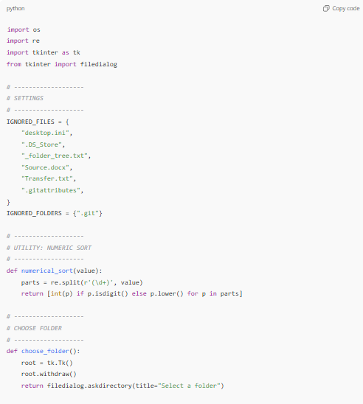
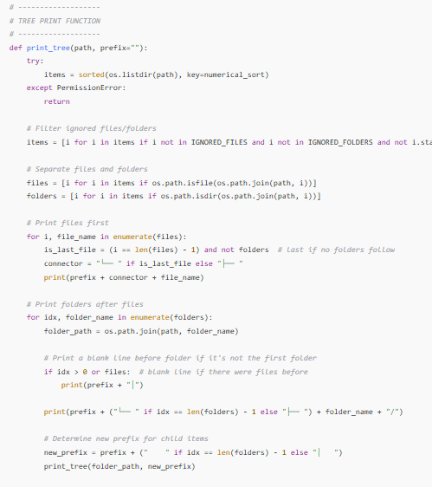
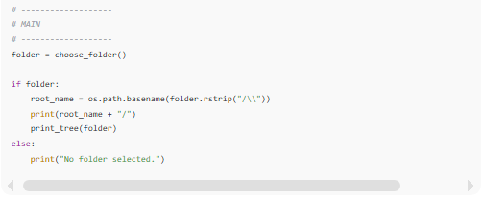
import os
import re
import tkinter as tk
from tkinter import filedialog

# -------------------
# SETTINGS
# -------------------
IGNORED_FILES = {
"desktop.ini",
".DS_Store",
"_folder_tree.txt",
"Source.docx",
"Transfer.txt",
".gitattributes",
}
IGNORED_FOLDERS = {".git"}

# -------------------
# UTILITY: NUMERIC SORT
# -------------------
def numerical_sort(value):
parts = re.split(r'(\d+)', value)
return [int(p) if p.isdigit() else p.lower() for p in parts]

# -------------------
# CHOOSE FOLDER
# -------------------
def choose_folder():
root = tk.Tk()
root.withdraw()
return filedialog.askdirectory(title="Select a folder")

# -------------------
# TREE PRINT FUNCTION
# -------------------
def print_tree(path, prefix=""):
try:
items = sorted(os.listdir(path), key=numerical_sort)
except PermissionError:
return

# Filter ignored files/folders
items = [i for i in items if i not in IGNORED_FILES and i not in IGNORED_FOLDERS and not i.startswith(".")]

# Separate files and folders
files = [i for i in items if os.path.isfile(os.path.join(path, i))]
folders = [i for i in items if os.path.isdir(os.path.join(path, i))]

# Print files first
for i, file_name in enumerate(files):
is_last_file = (i == len(files) - 1) and not folders # last if no folders follow
connector = "└── " if is_last_file else "├── "
print(prefix + connector + file_name)

# Print folders after files
for idx, folder_name in enumerate(folders):
folder_path = os.path.join(path, folder_name)

# Print a blank line before folder if it's not the first folder
if idx > 0 or files: # blank line if there were files before
print(prefix + "│")

print(prefix + ("└── " if idx == len(folders) - 1 else "├── ") + folder_name + "/")

# Determine new prefix for child items
new_prefix = prefix + (" " if idx == len(folders) - 1 else "│ ")
print_tree(folder_path, new_prefix)

# -------------------
# MAIN
# -------------------
folder = choose_folder()

if folder:
root_name = os.path.basename(folder.rstrip("/\\"))
print(root_name + "/")
print_tree(folder)
else:
print("No folder selected.")
✅ Why This Works
- Files are printed first in each folder.
- Folders are printed after files, with a blank line before them if there were files or they are not the first folder.
- Folders and files are separated so blank line logic is not affected by files.
- Tree connectors (├── / └──) are handled correctly.
- Blank line is printed before every folder except the first folder in a parent.
- Files are printed after folders with normal tree connectors.
- Ignored files/folders are skipped.
- Numerically sorted.

✅ What This Script Generates
Exact tree format like:
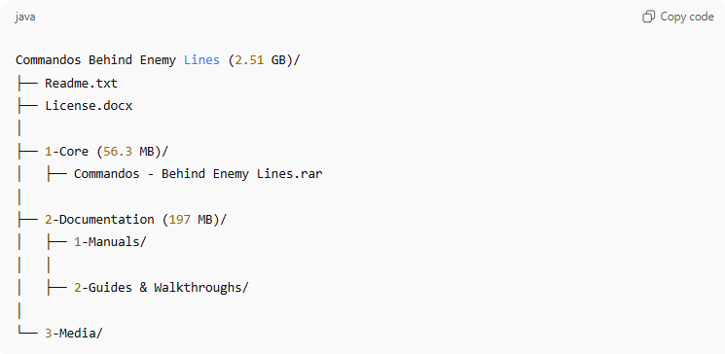
Commandos Behind Enemy Lines (2.51 GB)/
├── Readme.txt
├── License.docx
│
├── 1-Core (56.3 MB)/
│ ├── Commandos - Behind Enemy Lines.rar
│
├── 2-Documentation (197 MB)/
│ ├── 1-Manuals/
│ │
│ ├── 2-Guides & Walkthroughs/
│
└── 3-Media/

